Weißburgunder 2025
VDP.GUTSWEIN

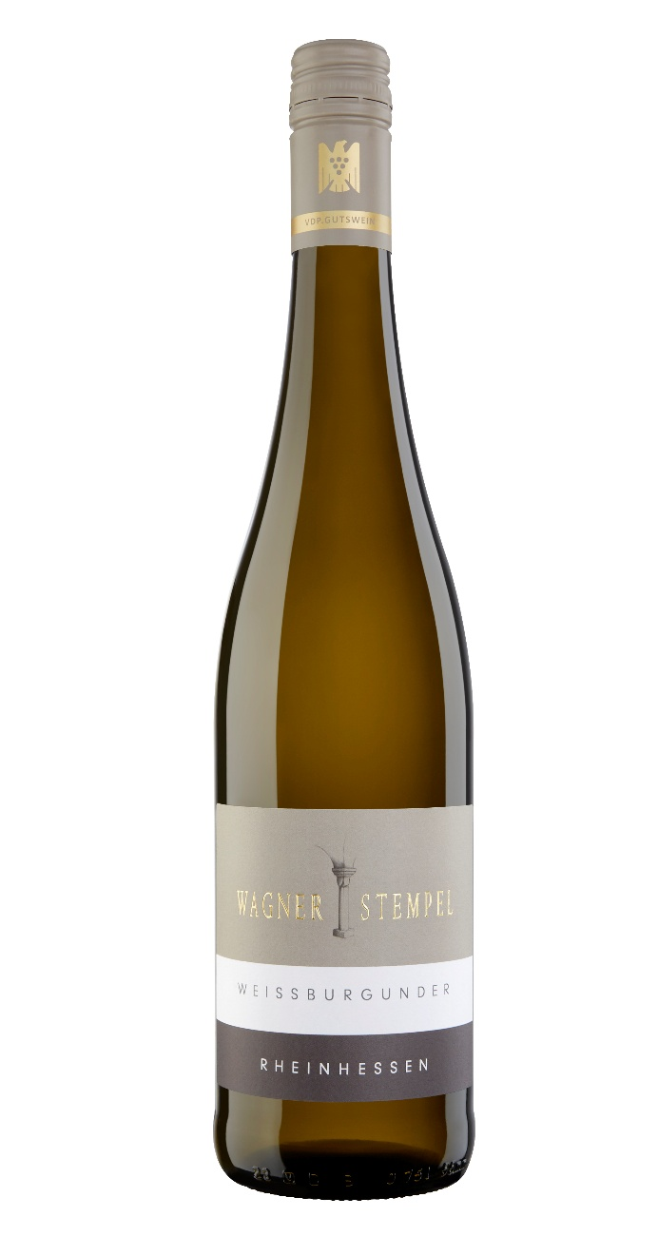

WINE DESCRIPTION

Clear, pale yellow colour with a light green tinges

Intense aromas of ripe apples, pears and quinces

Dry, fresh and invigorating acidity, high extract and minerality, medium body, very well balanced

SPECIAL FEATURES

Maturation: stainless steel tank, traditional large oak barrel of German oak.

Selectively hand-picked

Sourced from several vineyards in and around Siefersheim, predominantly sandy clay soil on a sub-soil of decomposed porphyry rock

Residual sugar 4,3 g/l
Acidity 5,1 g/l
Alcohol 12,0 % vol
